Click on the three dots and click on the run collection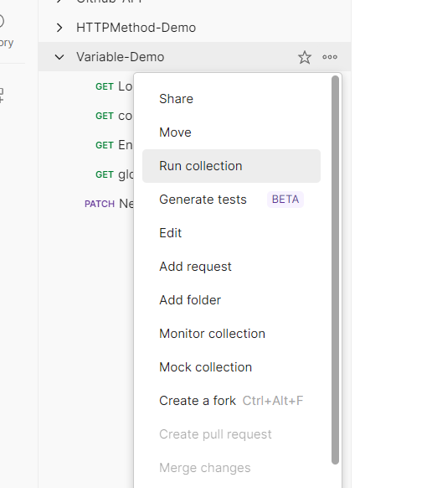

Click on the automate runs via cli

And click on the config command.

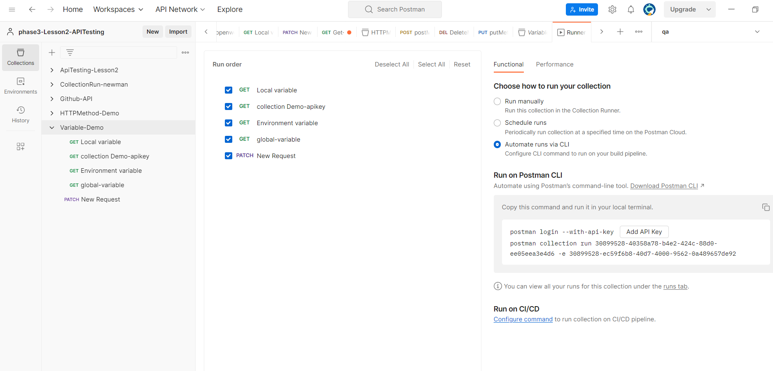

Select the collection ,environment, operating system,CD/CI configuration,and copy the script.

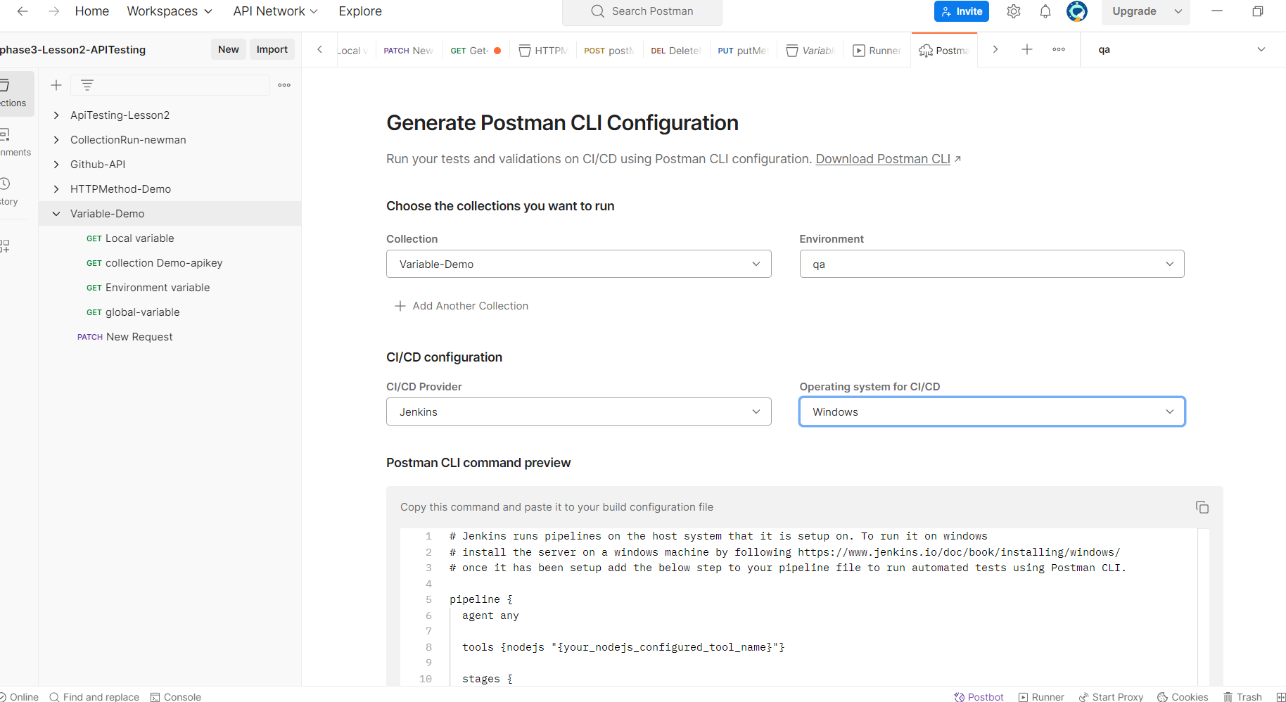

In Jenkins

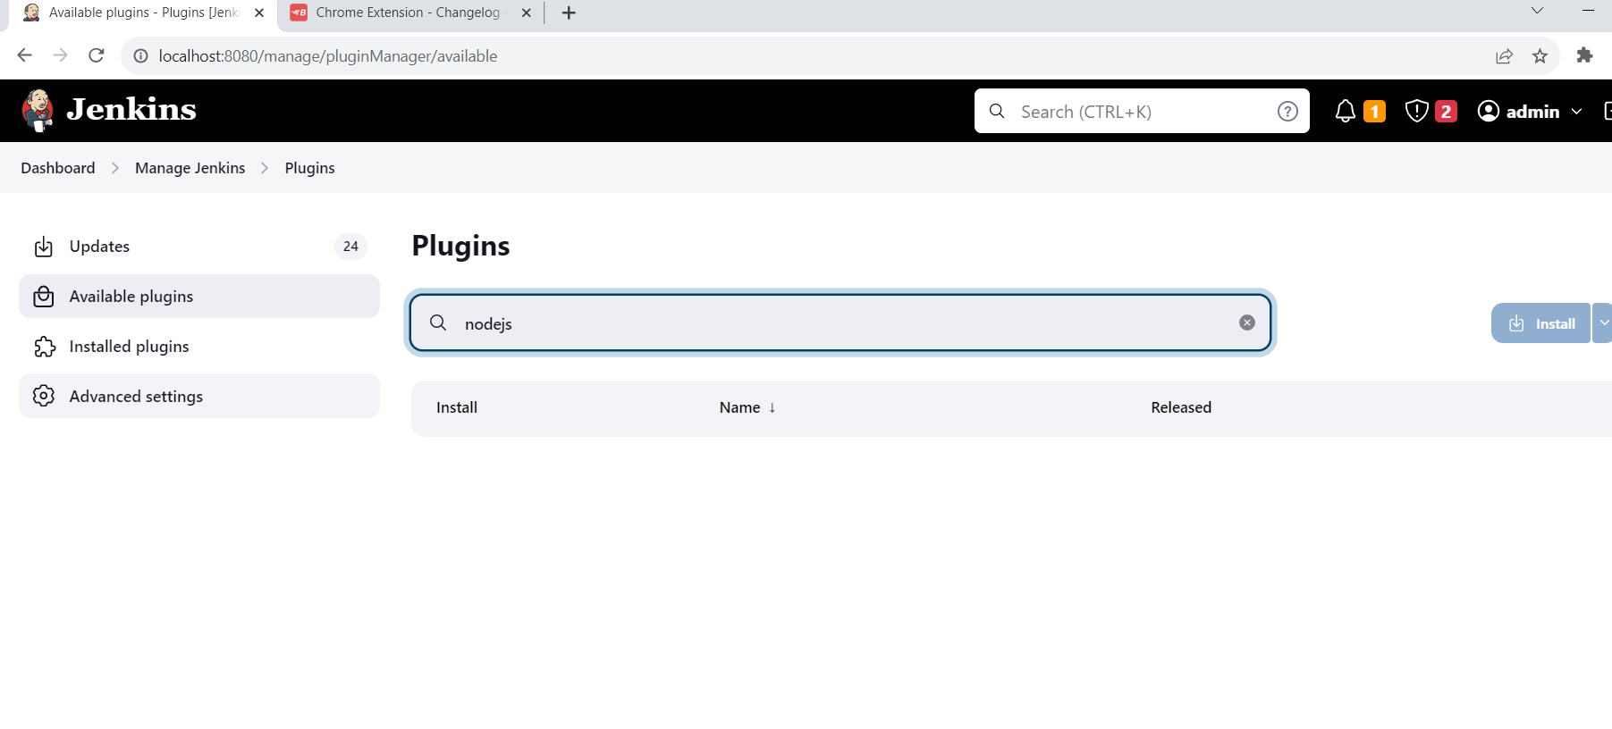install plugin nodejs.

Creating a job in jenkins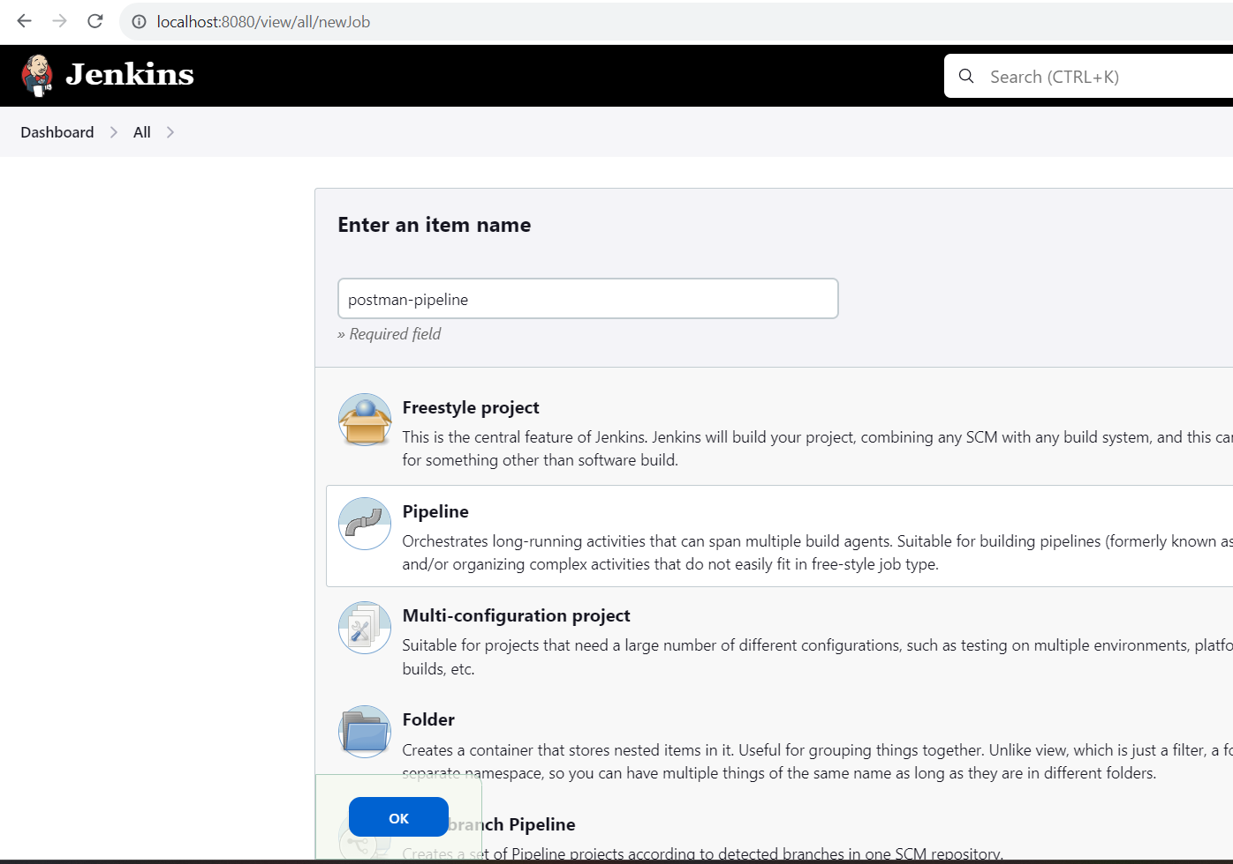

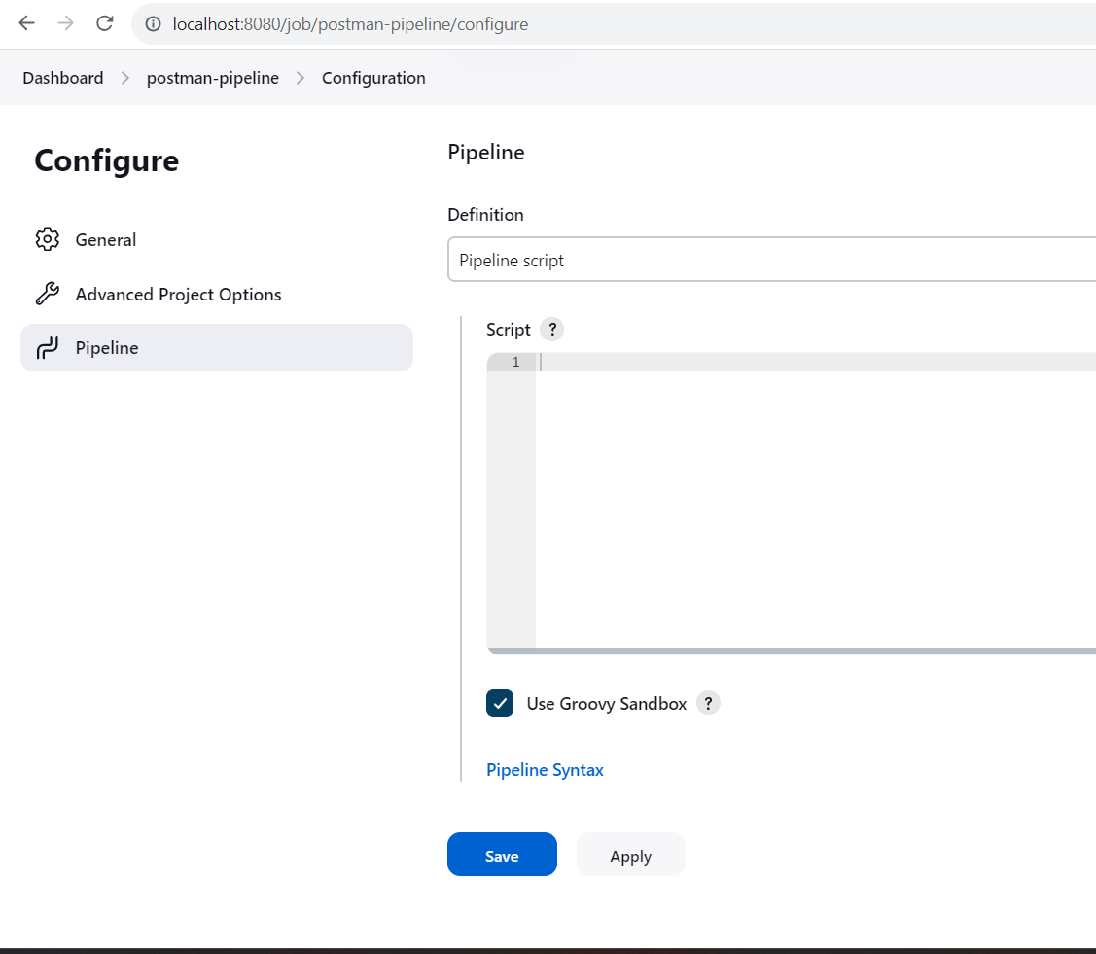

Paste the script

And editnumber-4=Node

9,15,21

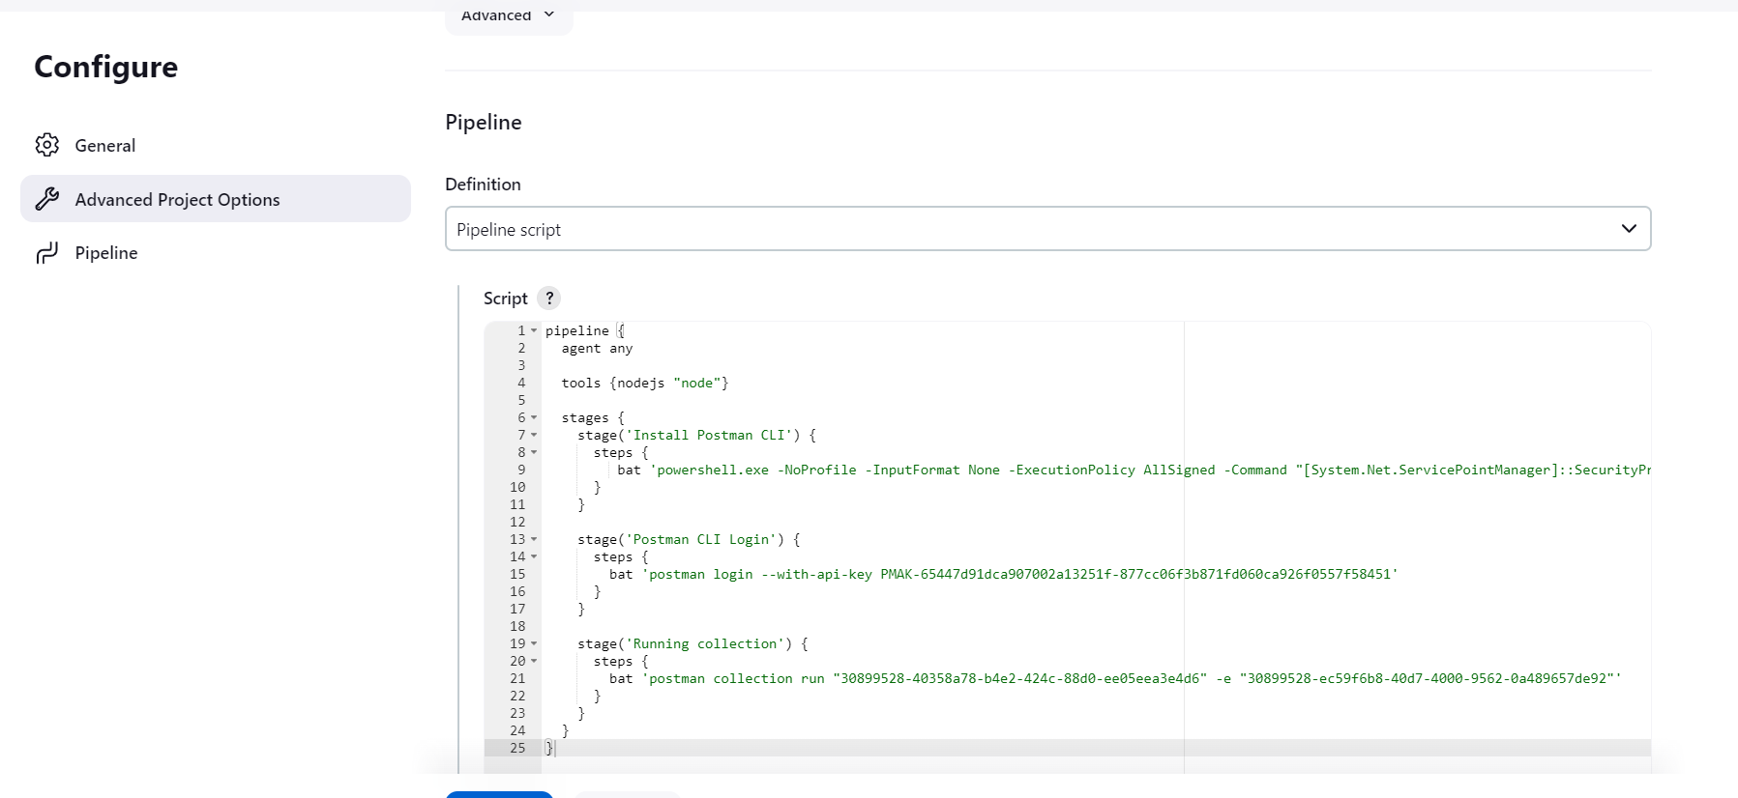

Click on build now.